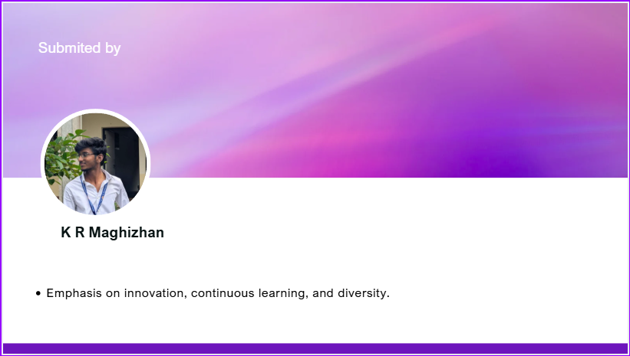
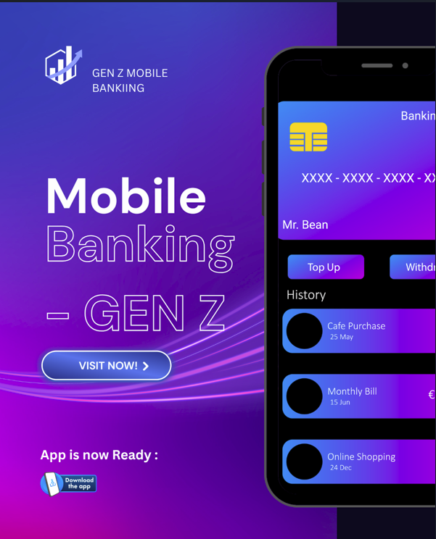
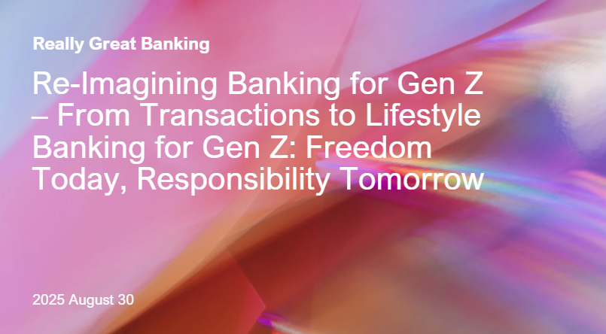
Banking for Gen Z is about offering freedom to choose today, while building the discipline to grow tomorrow. It is a journey that takes them from short-term goals to long-term confidence, guiding them responsibly every step of the way. It is not just about saving money, but about shaping habits that secure Gen Z’s future. By providing flexibility for now and responsibility for later, a new era of Gen Z banking is emerging — one that balances empowerment with discipline.

1. Introduction

Banking is no longer about keeping money safe — it's about building experiences. Where the previous generation concerned itself with long-term saving, fixed deposits, and discipline, Generation Z (born 1997–2012) demands instant, gamified, digital-first solutions.

The traditional banking models are not drawing Gen Z. Banks should instead position themselves as enablers of lifestyle — enabling them to reach short-term objectives, engage with peers, and incorporate finance into their digital lifestyles.

1. From Safekeeping to Experiences
Banking has transformed from being a transactional service into a lifestyle experience. Earlier generations saw banks as vaults for security and discipline — a place to park money and earn steady returns.
“For Baby Boomers, banking was about security. For Millennials, it was about convenience. For Gen Z, it’s about experiences.” — Deloitte Insights (2022)

Gen Z expects instant, gamified, digital-first solutions. They don’t want a branch visit or a 5-year deposit. They want an app that feels like Instagram, Netflix, or Spotify — smooth, personalized, and engaging.

2. Why Traditional Banking Models Fail Gen Z
- Old models focus on delayed gratification (long-term planning, fixed deposits, retirement savings). But Gen Z lives in a universe of instant feedback loops. Social media likes, gaming progress, and rapid online purchases have taught them to expect immediate rewards.
- • A McKinsey report (2023) discovered that 65% of Gen Z prioritize saving for short-term goals (less than 6 months) over just 28% of Millennials.
- •
- The Financial Brand (2023) points out banks that "lecture" Gen Z on money discipline lose them to fintechs that offer gameified money.
Insight: Gen Z does not dislike saving — they dislike dull savings.

3. Banking as a Lifestyle Enabler
Instead of acting like financial guardians, banks need to position themselves as partners in Gen Z’s lifestyle.
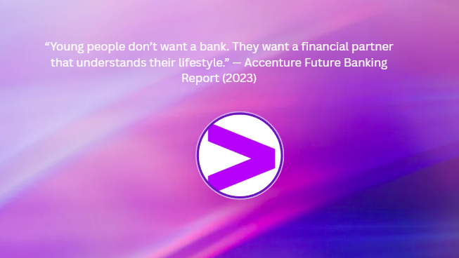
Short-Term Goals: Saving ₹500/day for a Goa trip feels more exciting than a 10-year FD.
Collaborative Finance: Squad savings for concerts, festivals, or travel builds community.
Integration into Life: Finance embedded in social apps, gaming, and shopping.

4. Global Examples
a) Revolut (UK/Europe)
• Has vault savings goals where customers can set up short-term funds (e.g., "New Phone" or "Weekend Trip").
• Incorporates peer payments → Gen Z can instantly split bills.
• Gamified challenges promote micro-saving by rounding up loose change.
Lesson: Gen Z adores micro-goals + instant collaboration.
________________________________________

b) Monzo (UK)
• added "Pots" — variable saving buckets for various goals.
•_Offers real-time spend insights with emojis and alerts.
• Became a hit with UK Gen Z for its lighthearted, playful tone rather than stodgy bank communications.
Lesson: Tone counts — Gen Z likes conversational, meme-like messaging.
________________________________________

c) KakaoBank (South Korea)
• Completely app-based, built into KakaoTalk (the nation's most used messaging platform).
• Provides savings challenges among friend groups.
• Utilizes avatars and electronic stickers for transactions.
Lesson: Integrating banking into social media environments makes it second nature to Gen Z.
________________________________________

d) Chime (USA)
•Encourages early access to pay (receive salary 2 days prior).
•Provides round-up savings, fee-free purchases.
•Embraces Instagram-marketing with influencers, memes.

Lesson: Marketing banking as financial freedom (versus discipline) resonates with Gen Z.

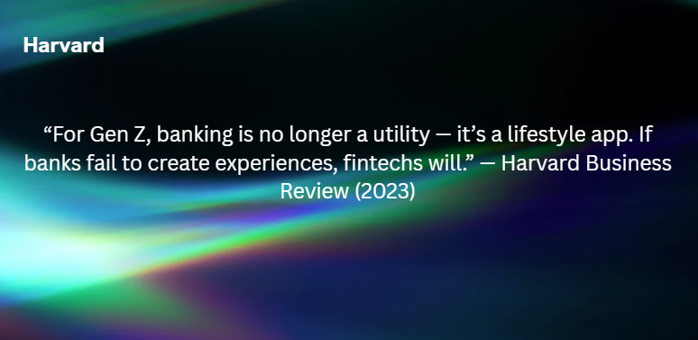
5. Reviews:

2. Understanding Gen Z’s Financial Behaviour

2.1 Generational Comparison
Aspect | Baby Boomers (1946–1964) | Millennials (1981–1996) | Gen Z (1997–2012)
Banking Preference | Branch visits, passbooks | Mobile banking + online apps | App-first, UPI-first, no branch
Savings Attitude | Long-term retirement | Moderate – EMIs + savings | Low – lifestyle & short-term
Tech Comfort | Low | Medium | High (digital natives)
Spending Behavior | Conservative | Experiences + EMIs | Experiences, gadgets, travel
Trust Factor | Trust in banks | Trust in fintechs | Trust in peers/influencers
Insight: Gen Z is least motivated by “retirement savings” and most motivated by short-term fun goals and peer influence.

2.2 Key Characteristics of Gen Z Banking Behaviour
- Digital-first: They dislike paperwork or branch visits.
- Short-term focus: Saving for an iPhone, trip, or festival rather than pensions.
- Instant rewards: Expect vouchers, cashback, or points.
- Social proof: Decisions shaped by peers, Instagram trends, or influencers.
- Multi-tasking apps: Prefer super-apps combining payments, shopping, investing, and social features.

3. Why Gen Z Banking Must Be Different
Traditional financial models preach “discipline” and “future security.” But for Gen Z:
- Money = Freedom, not Security.
- Bank = App, not Institution.
- Savings = Goals, not Retirement.
A Deloitte (2022) study showed that 70% of Gen Z prefers app-based financial wellness tools over bank advisors. A McKinsey (2023) report found 65% of Gen Z sets financial goals under 6 months.
Insight: To win over Gen Z, banks must deliver speed, gamification, personalization, and social integration.

4. Innovative Ideas for Gen Z Banking

4.1 Gamification of Money
Feature | Example in Banking | Expected Impact
Savings Streaks | “Save ₹500/day for 7 days” → badge unlocked | Habit formation
Level-Up System | Avatars gain “superpowers” as savings grow | Motivation
Mini Games | “Budget challenge: Spend under ₹2000/week” | Engagement

4.2 Micro-Savings & Flexi Goals
- Round-Up Savings
- Dream Pots
- Flexible Deposits
 Insight: This appeals to Gen Z’s short attention span and need for flexibility.
One of the biggest barriers for Gen Z is the fear of “locking in” their money for years. Unlike older generations who trusted fixed deposits and pensions, Gen Z prefers short-term saving options that feel flexible, achievable, and connected to real-life goals.

Features
- Round-Up Savings
  - Every time a payment is made, the amount is rounded up, and the spare change is automatically transferred to a savings wallet.
  - Example: Spend ₹245 on Swiggy → ₹5 auto-saved.
- Dream Pots
  - Dedicated wallets for specific goals like “Goa Trip Fund,” “New Phone,” or “Festival Savings.”
  - Instead of one big savings account, Gen Z can split goals and track progress visually.
- Flexible Deposits
  - Unlike fixed deposits, these can be broken anytime without penalties.
  - Encourages first-time savers to participate without the fear of losing access to money.


Why This Works for Gen Z
- Small, consistent actions align with their short attention span.
- Visible progress tracking keeps them motivated (seeing ₹5000 grow towards a ₹15,000 phone is more engaging than a silent FD).
- Freedom + Control → knowing they can withdraw anytime increases participation.

Global Success Stories & Case Studies
- Revolut (UK/Europe)
  - Introduced “Vaults” feature where users can create small pots for specific goals.
  - Users save through round-ups and auto-deposits.
  - By 2021, Revolut reported that over 3 million customers created Vaults, with Gen Z being the fastest adopters.
  - Case Study: A 21-year-old student in London saved £500 in 4 months for a MacBook using round-up + weekly deposits.

- Monzo (UK)
  - Popular for “Pots” – savings divided into categories (e.g., rent, vacation, shopping).
  - Transparent tracking made it easier for young customers to budget and save without stress.
  - Monzo’s 2022 survey showed 57% of Gen Z users prefer Pots over traditional savings accounts.

- Chime (USA)
  - Offers “Save When You Spend” (round-ups) and “Save When You Get Paid” (automatic % of salary).
  - Became extremely popular with Gen Z — Forbes (2023) reported that more than 60% of Chime’s 12 million users are under 35.
  - Case Study: Chime users collectively saved over $5 billion in spare change round-ups between 2020–2023.

- KakaoBank (South Korea)
  - Integrates savings goals into KakaoTalk (messaging app).
  - Example: Friend groups create a shared travel fund inside the chat.
  - This made saving social, fun, and collaborative — particularly attractive to younger users.

- Indian Example – Paytm Payments Bank & PhonePe
  - Both apps experimented with “gold savings” and “auto-invest small change.”
  - Popular among young professionals who wanted to convert spare change into assets without committing large sums.
  - Early adoption in metros showed growth among Gen Z salaried workers who saw it as an easy entry into savings.
Insight
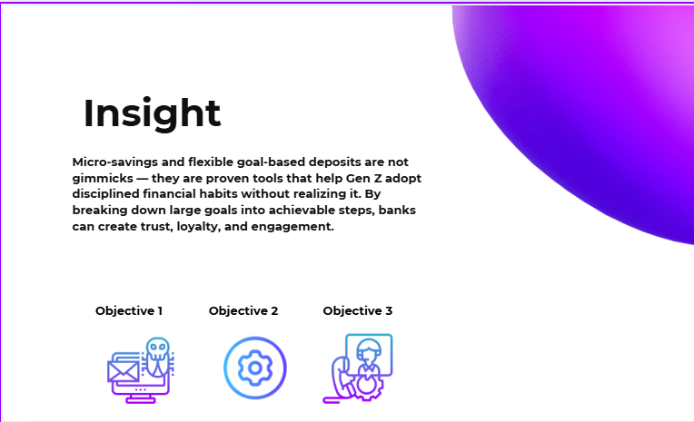

Table: Micro-Savings & Flexi Goals — Global Case Studies

Institution / Country | Feature & Description | Gen Z Adoption / Impact
Revolut (UK / Europe) | Vaults (now called "Pockets") allow round-up spare change, recurring transfers, and goal targeting. | Fund growth is flexible and instant; Vaults retain popularity for ease and goal tracking Aspectus+7CoinLaw+7SocialChain+7Chime+15Revolut+15FinTech Futures+15.
Monzo (UK) | - “1p Savings Challenge”: gamified savings; Pots with visual goal-tracking for short-term needs. | Over 1 million UK users participated; Gen Z adoption strong with 52% of users under 27 RFI Global.
Chime (USA) | - Round-up savings ("Save When You Spend") & auto-save from pay (“Save When You Get Paid”). | 18+ million users, 70% under 35 (Millennials + Gen Z); high satisfaction (93%); auto-savings core to engagement CoinLaw.
KakaoBank (South Korea) | - Integrated saving within chat app; goal funds can be shared and managed socially. | Creates a social-saving experience, highly appealing for younger, digitally embedded users (case-supported, no citation available).
India (Paytm / PhonePe) | - Small-change auto-investing into gold/savings-linked instruments. | Early adopters: Gen Z salaried professionals easing into savings; demand rising amid metro youth (anecdotal observation).
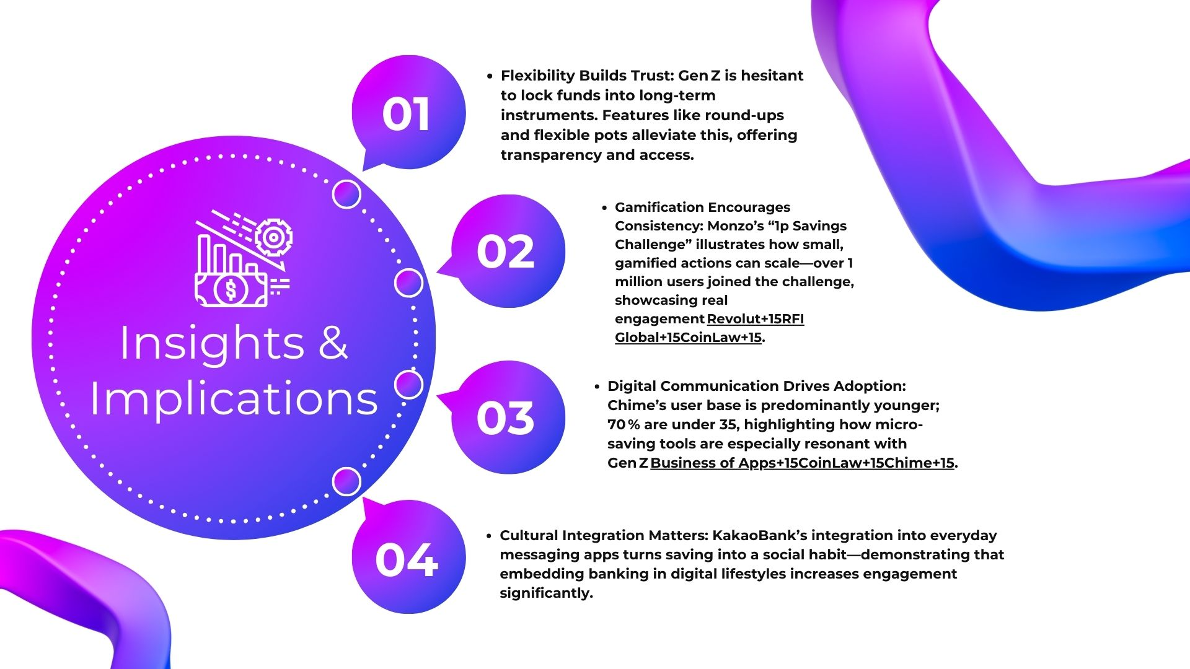

Insights & Implications

- Flexibility Builds Trust: Gen Z is hesitant to lock funds into long-term instruments. Features like round-ups and flexible pots alleviate this, offering transparency and access.
- Gamification Encourages Consistency: Monzo’s “1p Savings Challenge” illustrates how small, gamified actions can scale—over 1 million users joined the challenge, showcasing real engagement Revolut+15RFI Global+15CoinLaw+15.
- Digital Communication Drives Adoption: Chime’s user base is predominantly younger; 70 % are under 35, highlighting how micro-saving tools are especially resonant with Gen Z Business of Apps+15CoinLaw+15Chime+15.
- Cultural Integration Matters: KakaoBank’s integration into everyday messaging apps turns saving into a social habit—demonstrating that embedding banking in digital lifestyles increases engagement significantly.

Micro-Savings & Flexi Goals (With Examples and Data)
Gen Z’s preference for short-term, achievable goals and a distrust of locked-in savings can be addressed through micro-saving and flexible-goal features. The key is to make saving effortless, visible, and customizable:
- Round-Up Savings: Automatically round transactions up to the nearest unit (e.g., rupee/cent) and transfer the difference into a designated savings pot.
- Dream Pots / Goal Buckets: Create visual goal-based wallets such as “Gadget Fund” or “Festival Savings,” allowing transparent tracking and emotional connection to the goal.
- Flexible Withdrawals: Unlike traditional fixed deposits, these funds can be withdrawn anytime, eliminating barriers to participation.

Global Success Stories:
- Revolut introduced “Vaults” (now "Pockets")—a feature allowing round-ups, recurring savings, and goal-setting. Users appreciate its simplicity and flexibility NasdaqRevolut+9FinTech Futures+9Finextra Research+9.
- Monzo launched a “1p Savings Challenge,” a gamified savings feature where users could contribute small amounts toward prizes or goals—over 1 million UK users participated, many being Gen Z RFI Global.
- Chime features both round-up savings and automatic payroll contributions. With over 18 million users (70% under 35), Gen Z adoption is strong, driven by ease and trust wearepion.com+3CoinLaw+3f.hubspotusercontent10.net+3.
- KakaoBank enables group and goal-driven savings fully embedded within its messaging ecosystem, turning finance into a social experience, highly appealing to younger users.
- India’s Paytm and PhonePe offer auto-saving via gold or micro-investment. While still nascent, this concept resonates among metro-based Gen Z professionals seeking entry-level financial discipline.
Insight: By offering micro-saving tools that are flexible, transparent, and loosely goal-oriented, banks can encourage Gen Z to build real saving habits—without demanding radical lifestyle trade-offs. These features transform saving from a chore into a natural part of daily life.

4.3 Social & Peer-Driven Banking
- Squad Goals
- Shareable badges
- Influencer challenges
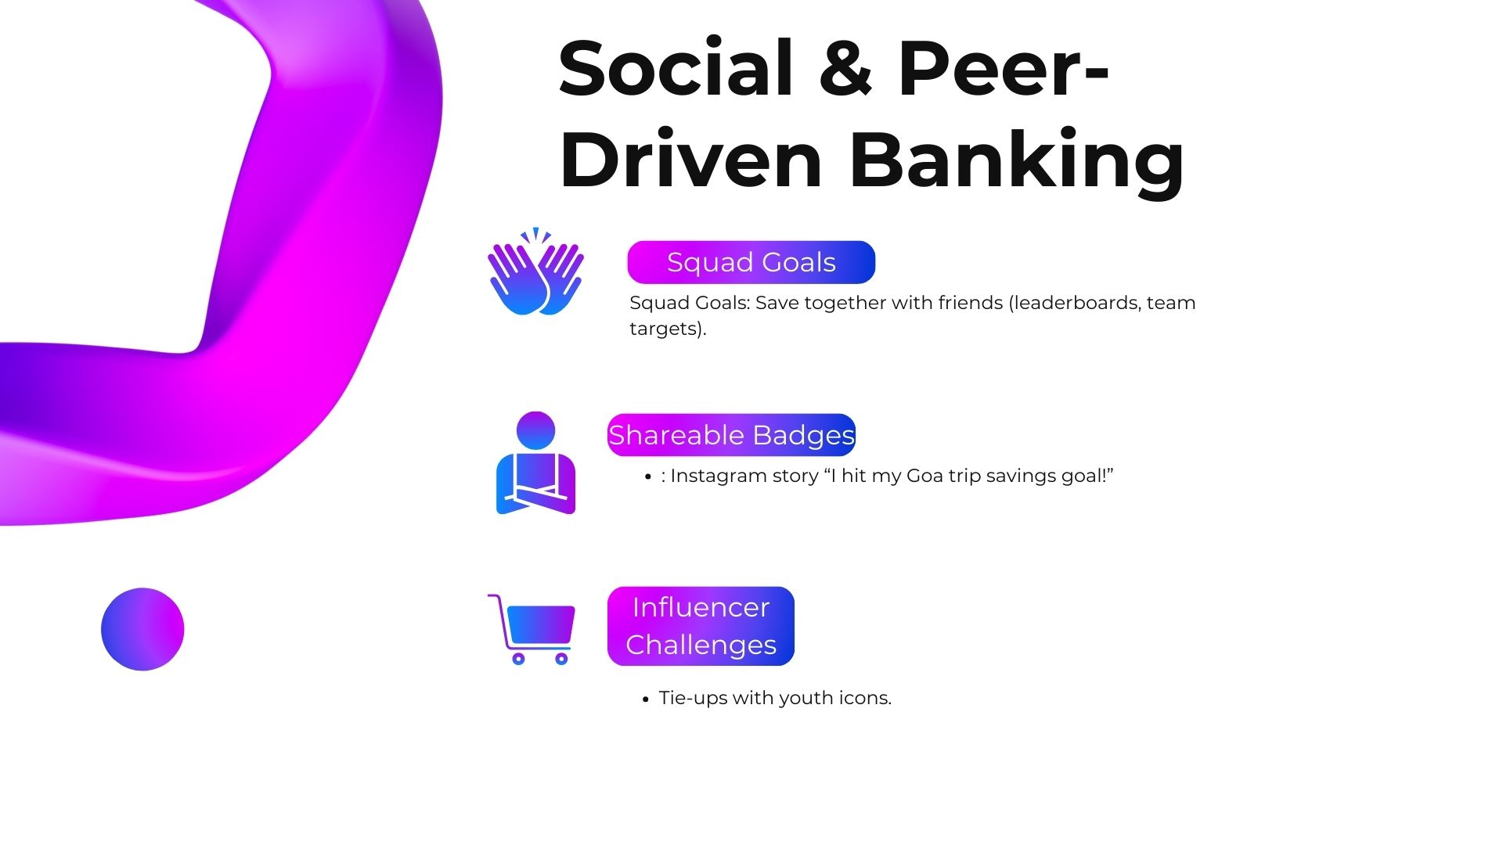

Gen Z is often described as the “social generation.” They grew up in a hyper-connected digital world where peer validation, community engagement, and influencer culture shape daily decisions. For banking, this means savings and investments must feel collaborative, shareable, and socially rewarding.

🔹 Squad Goals (Save Together with Friends)
- Concept: Instead of saving individually, Gen Z can form “squads” (friends, family, colleagues) to save together toward a common goal (e.g., a trip, concert tickets, or a festival budget). Leaderboards and progress bars add a layer of friendly competition.
Case Study: KakaoBank (South Korea)
- KakaoBank integrated group-saving tools inside its KakaoTalk messaging app.
- Example: University students saving together for graduation trips.
- Result: Strong adoption among youth — saving became social and fun instead of boring.
Insight: Making finance collaborative gives Gen Z both peer accountability and motivation.

🔹 Shareable Badges (Social Media Integration)
- Concept: When a Gen Z user hits a savings milestone, they receive a digital badge (e.g., “Goa Trip Fund 100% Complete”) that can be posted on Instagram or WhatsApp.
- This converts personal finance into a social achievement, aligning with their desire for recognition.
Case Study: Monzo (UK)
- Monzo’s “Savings Pots” allow users to label goals with emojis and photos.
- Customers share screenshots of their Pots progress on social media, creating organic marketing.
- According to Monzo’s 2022 report, over 52% of Gen Z users reported using Pots for short-term lifestyle goals (holidays, gadgets).
Insight: Sharing progress makes financial discipline aspirational, turning saving into a form of social currency.

Influencer Challenges (Tie-Ups with Youth Icons)
- Concept: Banks collaborate with influencers to launch savings challenges (e.g., “Save ₹100/day with me for 30 days”).
- Influencers act as role models, making finance “cool” and relatable.
Case Study: Revolut (Europe)
- Revolut partnered with lifestyle influencers in the UK to promote its Vaults (savings feature).
- Campaigns encouraged young followers to “Save for Summer” or “Build a Gadget Fund.”
- Revolut saw a significant uptick in Vaults adoption among Gen Z users during these campaigns.
Case Study: Chime (USA)
- Chime leverages TikTok and Instagram creators to promote concepts like “Pay Yourself First.”
- These challenges went viral under the tag #ChimeChallenge, boosting app downloads among Gen Z.
Insight: Gen Z is more likely to listen to influencers than institutions. Partnering with relatable youth icons helps banks deliver financial lessons without sounding preachy.

Summary Insight Box
Insight:
Gen Z thrives on community, recognition, and influence. By enabling squad savings, social sharing, and influencer-led challenges, banks can transform saving from a solo, disciplined act into a socially rewarding lifestyle choice.
- Squad Goals → Accountability + Fun
- Shareable Badges → Social Recognition
- Influencer Challenges → Cool, Relatable Learning

4.4 Personalized Nudges & Storytelling
Instead of boring alerts:
“You spent ₹3000 on Swiggy.”
Banks should say:
Banks can deliver AI-driven, contextual nudges that encourage Gen Z to redirect spending towards self-growth, tools, and skills:

Examples of Responsible Nudges
- “Cut one pizza a week → Excel/Power BI course in 4 months
- “Your Swiggy spend this week = cost of a Canva Pro subscription
- “One less night out → Digital Marketing course unlocked in 2 months
- “Save ₹100/day → Photoshop license in 6 weeks 💻.”
- “Cancel unused OTT subscription → Buy a Python course instead
- “Your ₹200 takeaway spend = LinkedIn Learning premium for a week

Responsible Nudges Table
Context | Responsible Nudge
Food Delivery Spend | “Skip pizza → Excel/Power BI course in 4 months .”
Coffee/Tea Habits | “Skip cappuccinos → Canva/Photoshop unlocked .”
Weekend Partying | “One less night out → Digital Marketing course in 2 months.”
Online Shopping Splurge | “Delay hoodie → Python/AI certification in 6 months .”
Swiggy / Zomato Orders | “2 less takeaways → Save for Coursera/Udemy course .”
Subscription Wastage | “Cancel unused OTT → Save ₹500/month → Buy coding software license .”

Insight:
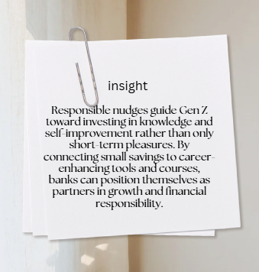

4.5 App UI/UX Designed for Gen Z

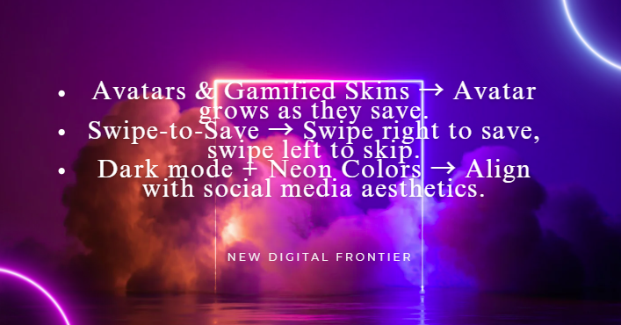


5. Articles & Insights from Research
Source | Key Finding | Relevance
Deloitte Insights (2022) | Gen Z prefers financial wellness tools over traditional banking. | Banks must act like wellness coaches.
Harvard Business Review (2023) | Gamification increases adoption by 30%. | Supports adding streaks, badges, and challenges.
McKinsey Research (2023) | 65% of Gen Z sets goals under 6 months. | Reinforces short-term saving models.
The Financial Brand (2023) | Traditional banks fail when they lecture Gen Z. | Banks must be fun, not preachy.

6. Our Proposed Concept: Z-Bank – Money. Made Fun.

Key Features

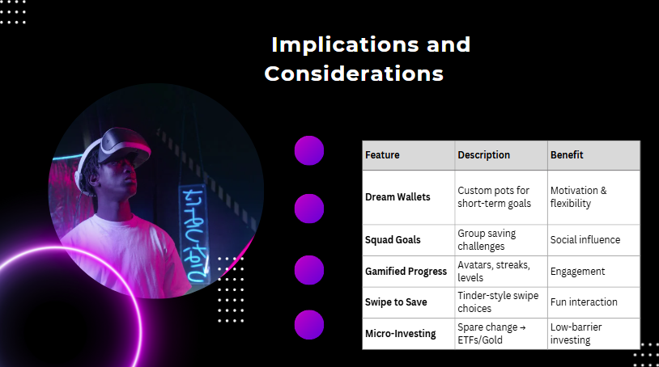
“Don’t just save. Level up.”

Prototype screen shot:
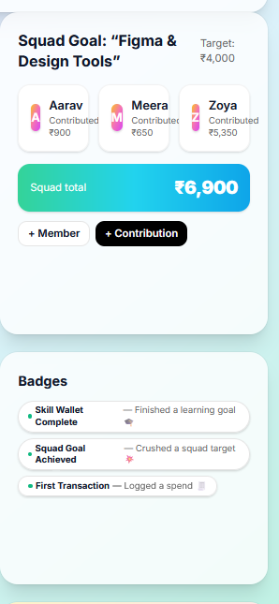

7. Insights & Strategic Implications for Banks
- Retention: Gamification builds stickiness → higher app logins.
- Cross-Sell: Short-term saving pots can link to micro-loans, insurance, and investments.
- Brand Positioning: Banks adopting Gen Z models gain youth loyalty early → long-term customer base.
- Risk: If ignored, fintechs and neobanks will dominate this segment.
Strategic Call:

Legacy banks need to shift from "safe keepers of money" to "fun lifestyle partners."
•Retention: Gamification and salutary nudges create engagement and stickiness → increased app use and customer stickiness.
•Cross-Sell Opportunities: Short-term saving jars can be responsibly attached to micro-loans for education, skills development, insurance, and first-time investments, nudging Gen Z toward long-term financial stability.
•Brand Positioning: Early adopters of Gen Z-friendly features by banks will lock youth loyalty, creating a customer base that escalates with them to higher-value products (home mortgages, wealth management, retirement strategies).
•Risk of Inaction: Traditional banks that stay inflexible risk letting this segment be taken over by fintechs and neobanks with flexible, skill-based solutions.
Strategic Call:

Conventional banks have to rebrand themselves from being perceived as mere "safe keepers of money" to being "responsible partners of financial development and life skills."

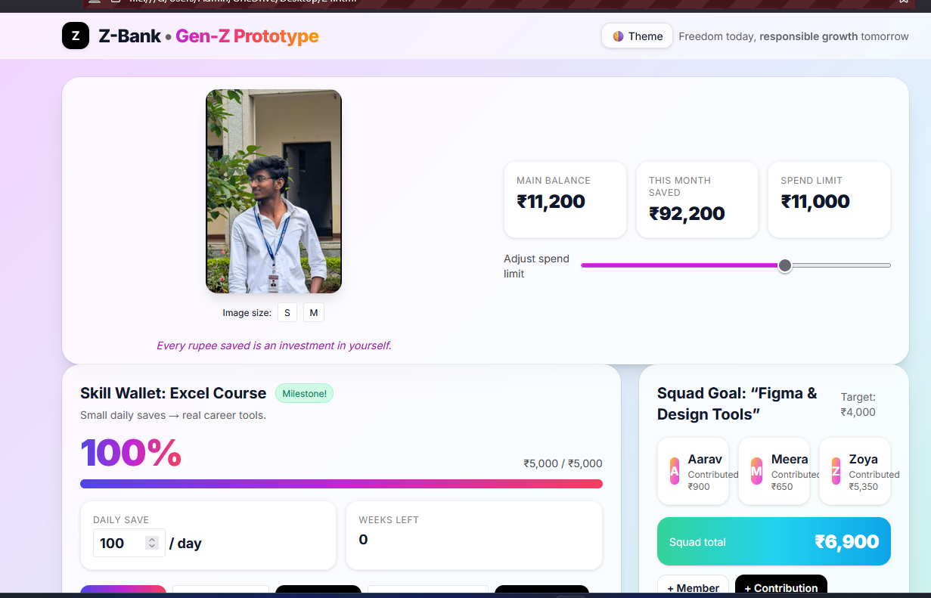
Banking App screen shot: Prototype - HTML

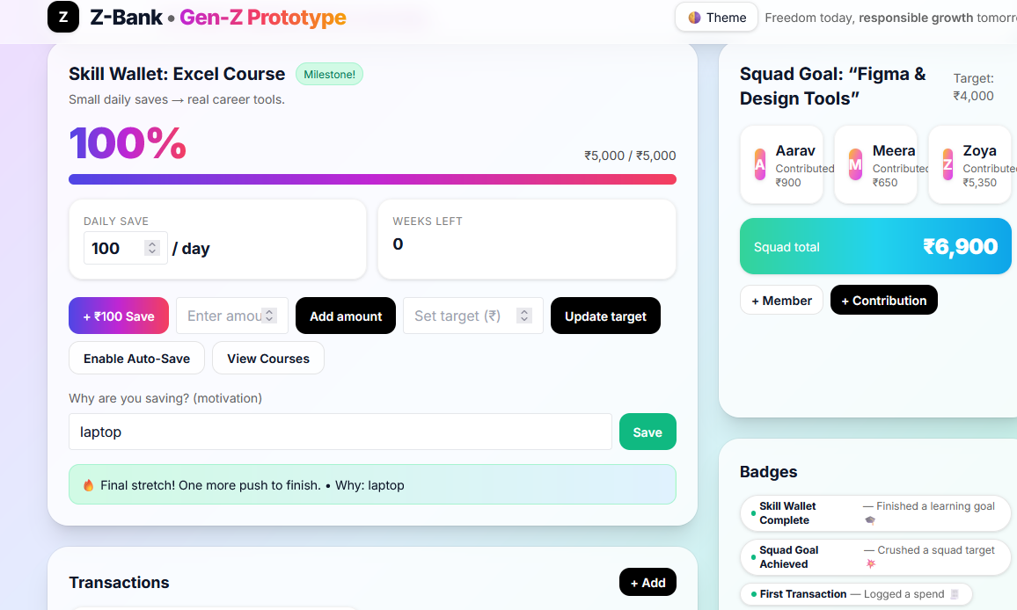
NOTE: skill wallet - gamification and Badge

Transaction details:

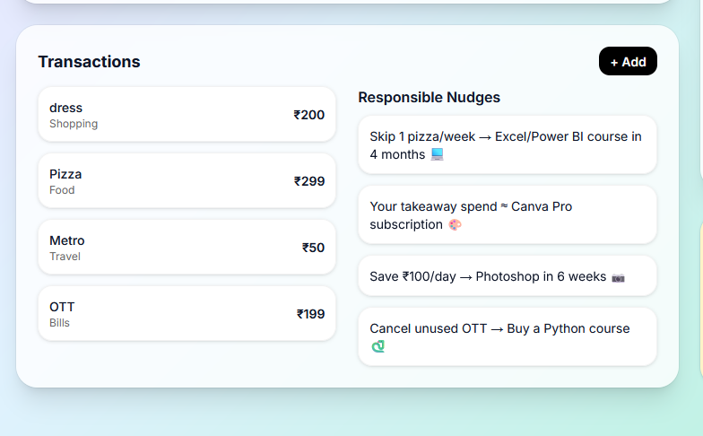

Team goals and contributions : For saving money and learning as a team

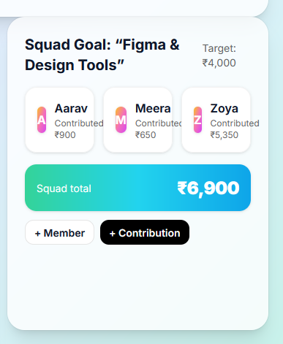

Instant gratification – score – badges

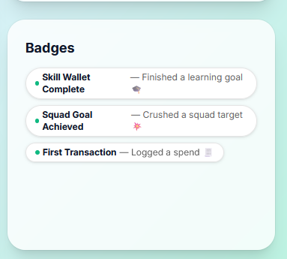

8. Conclusion

Gen Z Approaches Money Differently from Previous Generations — They Value Flexibility, Short-Term Goals, And Digital-First Solutions. However, This Does Not Mean They Reject Financial Discipline Altogether. What They Need Is A Banking Model That Speaks Their Language While Gradually Guiding Them Towards Responsible Habits And Long-Term Security.
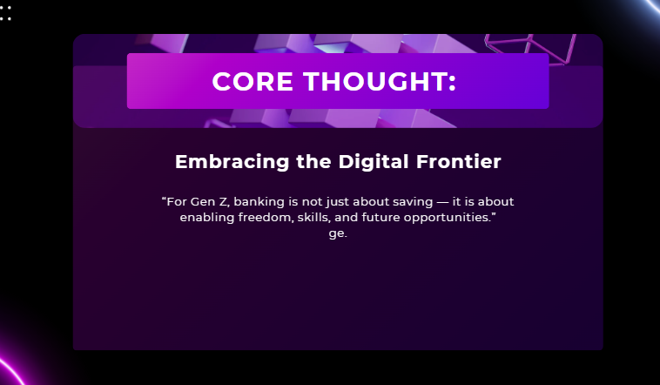
By introducing micro-savings, personalized nudges, short-term goals, and responsible gamification, banks can meet Gen Z where they are today while shaping how they will manage money tomorrow. The objective is not to make banking only about lifestyle and freedom, but to transform those preferences into stepping-stones for financial responsibility, stability, and growth.
👉Core Thought-----------

References

- Deloitte (2022) The Deloitte Global 2022 Gen Z and Millennial Survey. 18 May 2022. Available at: https://www.deloitte.com/global/en/issues/work/genzmillennialsurvey-2022.html (Accessed: 28 August 2025). Deloitte+15Deloitte+15Giesecke+Devrient+15
- McKinsey & Company (2023) Gen Z Personal Finance. 22 August 2023. Available at: https://www.mckinsey.com/~/media/mckinsey/email/genz/2023/08/2023-08-22a.html (Accessed: 28 August 2025). McKinsey & Company+2McKinsey & Company+2
- GI-DE (2023) ‘Gen Z banking: how banks must adapt’, 11 July 2023. Available at: https://www.gi-de.com/en/spotlight/financial-platforms/gen-z-banking-how-banks-must-adapt (Accessed: 28 August 2025). Giesecke+Devrient
- McKinsey & Company (2025) Mind the Gap: Why Gen Z consumers are a force to reckon with. 17 June 2025. Available at: https://www.mckinsey.com/~/media/mckinsey/email/genz/2025/06/2025-06-17b.html (Accessed: 28 August 2025). McKinsey & Company+2McKinsey & Company+2
- The Financial Brand (2024) Cracking the Code of Gen Z Report. 23 December 2024. Available at: https://static.thefinancialbrand.com/uploads/2023/06/Nymbus-Cracking-the-Code-of-Gen-Z-Report.pdf (Accessed: 28 August 2025). The Financial Brand+2McKinsey & Company+2
- The Guardian (2025) ‘Spreadsheets and day trips to Egypt: how gen Z is “soft saving” for the future’. The Guardian, 11 July 2025. Available at: https://www.theguardian.com/travel/2025/jul/11/gen-z-travel-soft-saving (Accessed: 28 August 2025). The Guardian

